PROVISIONAL MARKING KEY
PHYSICS I

CEED MOCK PHYSICS PAPER I PROVISIONAL MARKING SCHEME
QUESTION 1
1. a. i. temperature (1)
ii. - volume of gas (1)
- mass of gas (1)
iii. – to analyse data (1)
- to even out errors (1)
b. i. micrometer screw gauge
ii. 12.95mm

QUESTION 2
1. a.Average time taken for the half of the sample to be reduced to half its original size(1)
b. ${ fraction= (\frac{1}{2})}^{\frac{T}{t_{\frac{1}{2}}}}$ (1)
$fraction{ = \left(\frac{1}{2}\right)}^{\frac{84}{14}}$ (1)
$={(\frac{1}{2})}^{6}$
$=\frac{1}{64}$ (1)

OR

After 14 days = ½
After 28 days = ½ x ½ = ¼ (1)
After 42 days = ½ x ½ x ½ = 1/8
After 56 days = ½ x ½ x ½ x ½ = 1/16 (1)
After 70 days = ½ x ½ x ½ x ½ x ½ = 1/32
After 84 days = ½ x ½ x ½ x ½ x ½ x ½ = 1/64 (1)
(Every two correct steps = 1mark)

QUESTION 3
3.a length of line drawn to scale represents magnitude /(1) while arrowhead on the line represents direction. /(1)
b. light material in order to reduce mass, /(1) powerful engine in order to increase exerted force /(1) so as to increase acceleration of a racing car. /(1)
c. $m_{1}u_{1}+ m_{2}u_{2}=v(m_{1}+ m_{2})$ (1)
$15 x 20+10 x 8=v(15+10)$ (1)
$$v= \frac{380}{25}$$
$=15.2 m/s$ (1) with correct or without units
d. The theory state that matter is made up of small particles/molecules which are in constant motion, in all directions and at high speed.(1)
QUESTION 4
(a). It states that if no external forces act on it, the total momentum of bodies before collision is equal to total momentum of bodies after collision .(1)
Total momentum of bodies before collision is equal to the total momentum after collision
b - resistance of the coils
- Eddy Currents
- - Hysteresis losses
- - magnetic / flux leakages (any 2 for 2 marks)
c.i. Is the force that keeps an object in motion to move at a fixed distance from the centre. .(1)
ii. -Motion of artificial satellites around the earth
-when a car is going around a circular path on horizontal road.(1) the centripetal force is required for circular motion
- Banked tracks.
- conical pendulum
- aircraft taking a circular turn
- A cyclist going around a curved leans in ward to provide the necessary centripetal force1 , so as to be able to go along the curved track . (any 1 for 1 mark)

QUESTION 5
5. a. $cost=power x timex charge per unit$ (1)
$$power=VI=240 x 25=6000=\frac{6000}{1000}=6kW$$
$cost=6 x 1.5 x 200$ (1)
$= K1800$ (1)
b. i.
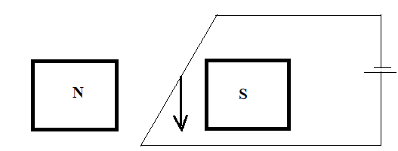
ii. - increasing amount of current (1)
- using stronger magnet (1)

iii. - electric motor (1)
- loud speaker (1)
- ammeter
ANY ONE

QUESTION 6
6.a.
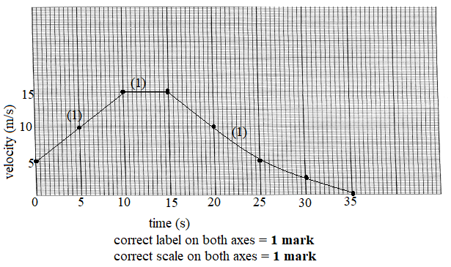
b. $s=l xw$
$=15 x 5$ (1)
$=75m$ (1)
c. - Reflection
- Refraction
- Diffraction (any 1 for 1 mark)
- Interference
d. Free vibration occurs in the absence of any resistive force (1)while
-forced vibrations occur when there is a small amount of resistive force (1)

QUESTION 7
7.a. Amount of work done is equal to the amount of energy used. (1)
b. Efficiency =$\frac{ M.R}{V.R} X\frac{100}{1}$ (1 for correct formula)
MA = $\frac{L}{E}=\frac{400N}{8N}$=5 (1 for correct substitution)
Eff = $\frac{5}{8} X 100$
= 62.5% (1 for correct response)
c. i. measures Electromotive force
ii. measures Potential difference
(ii). Some voltages in (i) is used to overcome internal resistance of the cell (1)while there is no resistance in (ii) as there is no work done (1)hence Pd higher than emf.
QUESTION 8
8.a. i. digital electronic signal (1)
ii. - it is time discrete (1)
- it is represented by square waves(1)
- it is binary format (1)
- it has bit interval (1)

ANY TWO
b. P is OR gate (1)
R is NAND gate (1)

QUESTION 9
9.a. i. K
ii. it has higher frequency/(1) due its shorter wavelength /(1) than J
b. - The camera’s lens has fixed focal length while human eye’s lens has focal length that can change by changing shape. /(1)
- Image distance in a camera can change while image distance in the human eye cannot change/(1)
- Camera produces clear image through focusing while a human eye produces clear image through accommodation. /(1)

ANY TWO

QUESTION 10
10. a.
- Heat is measured in joules while temperature is measured in degrees Celsius or Kelvins. /(1)
- Heat refers to the amount of energy in an object while temperature refers to the intensity of heat (degree of coldness or hotness). /(1)
- Heat is measured by Calorimeter while temperature is measured by thermometer. /(1)
- Heat is total kinetic energy of all molecules in a substance while temperature is a measure of the average kinetic energy of molecules in a substance. /(1)

ANY ONE
b.i. States that pressure of fixed mass of gas is directly proportional to the absolute temperature provided that volume is kept constant. /(1)
ii. Heating air inside the balloon makes it lighter /(1) than the air outside and this makes the balloon to float upwards /(1)

QUESTION 11
11. a.
- Arm B is left open to atmospheric pressure while Arm A is connected to the mouth of a person. /(1)
- Air should be blown strongly from the mouth through the tube but once. /(1)
- The pressure difference due to air from the lungs of a person via mouth pushes water around the u-tube, / (1) creating a height difference in water levels /(1)
- The height difference in water levels is recorded. /(1)
- The lung pressure is then calculated using the formula P = ρhg + atmospheric pressure /(1)

b. Place steel needle on the bench /(1)
- Stroke the steel needle with the bar magnet along the whole steel needle. /(1)
- Once at the end, lift the bar magnet well away from the needle and stroke it from the same position. /(1) (OR repeat step 2 in the same direction several times)
- Test the polarity of the steel needle using repulsion method /(1)
QUESTION 12
12.a.
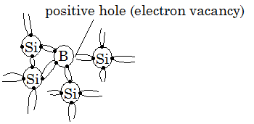
correct diagram with correct number of valence electrons = 1 mark
Labeling of elements and a hole = 1 mark
- One silicon atom in a crystal is replaced by boron, which has three valence electrons. / (1)
- All three valence electrons of boron form bonds with three silicon atom, creating a shortage of electron on boron that could be used to bond this fourth silicon atom near it. / (1)
- Electron from fourth silicon atom moves in to occupy the hole on boron, leaving another hole behind on silicon. /(1)
- Electron then moves back to a fill a vacancy on silicon, leaving another hole on boron and so on. So, there is a pattern of flow of electron and a hole in opposite directions, to give rise to electrical conductivity. /(1)

b. Due to a fault the live wire becomes loose /(1) and touches the metal body of electric kettle, /(1) current immediately flows to earth wire /(1) that carries it from the metal body to the ground. /(1).This makes the metal body safe to touch

QUESTION 13
13.a.
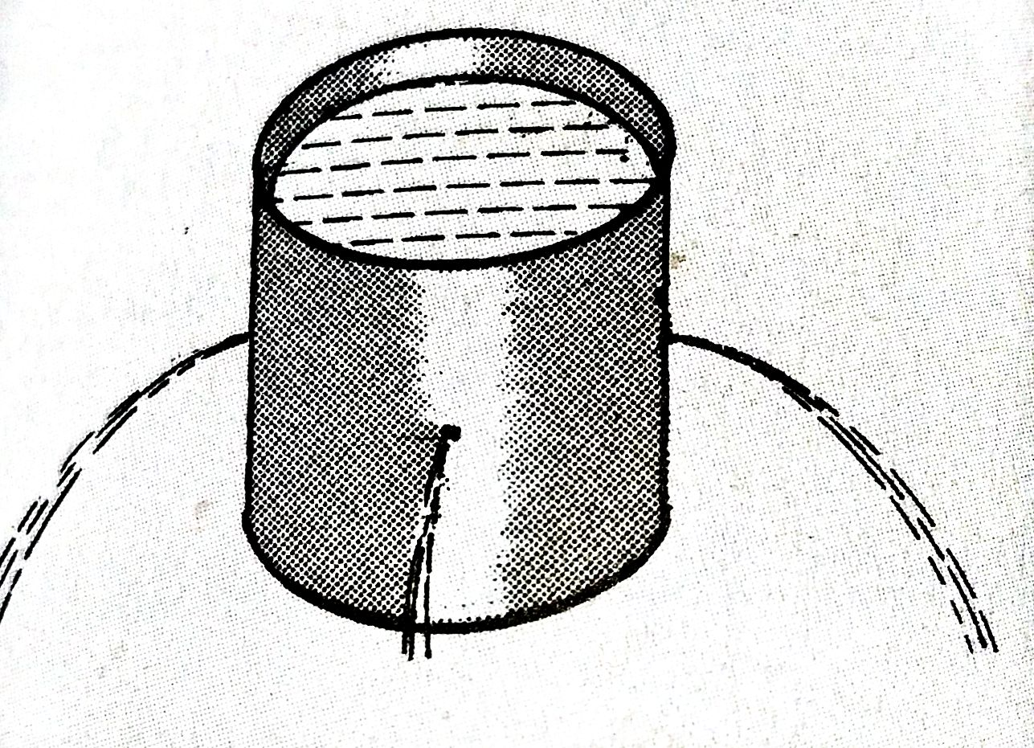

Labelling the can /(1).
Labelling the water jets /(1).
Correct diagram /(1).
-Take a can and make similar holes at the same height around it. /(1).
-Fill the can with water /(1).
b.
-Compare the distances the water jets get out of the can. /(1).
- By adding a small amount of a radioisotope /(1). which is a source of beta radiation the fluid. /(1).
- The area where there is a leak /(1).will show a high count rate of the radiation. /(1).

